### 

**EVOLUTION OF WOMEN CHARACTERS IN ADOOR GOPALAKRISHNAN’S FILMS 1950’S TO 2000’S**

## *A Dissertation Submitted in the Partial Fulfillment of the Requirements for the award of the Degree of (Italics)*

## Master of Arts

## In

## Communication and Media Studies

# by

Wafa Muhammed Nooh

REG. NO: 22PMS130

(Marian College logo, to be put only after the acceptance of dissertation/thesis for award of degree the logo should not be more than 4.5 cm2 area)

**Department of Communication and Media Studies**

**Marian College Kuttikkanam Autonomous**

2022- 2024

**EVOLUTION OF WOMEN CHARACTERS IN ADOOR GOPALAKRISHNAN’S FILMS 1950’S TO 2000’S**

## *A Dissertation Submitted in the Partial Fulfillment of the Requirements for the award of the Degree of (Italics)*

## Master of Arts

## In

## Communication and Media Studies

# by

Wafa Muhammed Nooh

REG. NO: 22PMS130

(Marian College logo, to be put only after the acceptance of dissertation/thesis for award of degree the logo should not be more than 4.5 cm2 area)

**Under the Supervision of**

**Fr Sobi Thomas Kannalil**

**Head of the Department**

**Department of Communication and Media Studies**

**Marian College Kuttikkanam Autonomous**

May 2024

**APPROVAL OF DISSERTATION**

The Dissertation entitled “***EVOLUTION OF WOMEN CHARACTERS IN ADOOR GOPALAKRISHANAN’S FILMS 1950’S TO 2000’S***” by **WAFA MUHAMMED NOOH, 22PMS130** is approved for the awardif the degree of MA in Communication and Media Studies.

Supervisor :

General Research Coordinator : Mr Sherin P Shaji

Head of then Department : Fr. Sobi Thomas

Director : Prof. M Vijayakumar

Date:

Place: Kuttikkanam (Seal)

**CERTIFICATE**

**DECLARATION**

I Wafa Muhammed Nooh hereby declare that the dissertation entitled **" *EVOLUTION OF WOMEN CHARACTERS IN ADOOR GOPALAKRISHNAN’S FILMS 1950’S TO 2000’S*"** submitted to Marian College Kuttikkanam Autonomous in the partial fulfillment of Master of Arts in Communication and Media Studies, is a record of original and independent dissertation work concluded during the period of 2023 November to 2024 May under the supervision and guidance of **(NAME OF THE GUIDE AND DESIGNATION**),Department of Communication and Media Studies. This dissertation in whole or part has not been previously submitted for any Degree, Diploma, Associate ship, Fellowship or either similar degree of this or any other university. Materials obtained from other sources are duly acknowledged in this thesis.

Place: Kuttikanam Wafa Muhammed Nooh

Date: 18/12/2023 Reg. No: 22PMS130

Department of Communicatin and Media Studies

Marian College Kuttikanam Autonomous

**CERTIFICATE**

**CERTIFICATE**

This is to certify that dissertation entitled "EVOLUTION OF WOMEN CHARACTERS IN ADOOR GOPALAKRISHANAN’S FILMS 1950’S TO 2000’S”, submitted to Marian College Kuttikkanam Autonomous is a record of original work conducted by WAFA MUHAMMED NOOH, 22PMS130 during the period, 2023 November to 2024 May under my guidance and supervision, for the partial fulfillment of Master of Arts in Communication and Media Studies. This Dissertation in whole or part has not been previously submitted for any Degree, Diploma, Associate ship, Fellowship or either similar degree of this or any other university. Materials obtained from other sources are duly acknowledged in this thesis.

Place [Name and signature of supervisor]

Date [Designation]

Department of Communication and Media Studies

Marian College Kuttikanam Autonomous

### ACKNOWLEDGEMENTS

Type your acknowledgements here (One page only)

Name and signature of student

### Annexure –VI

**ABSTRACT**

**[Type title of dissertation/thesis here]**

Name of student:

Registration number:

Degree for which submitted:

Name of supervisor:

Name of College:

### Type your abstract here in single space

***Key words*** (Five minimum):

(Name and signature of student) (Name and signature of supervisor)

### TABLE OF CONTENTS

[Type your table of contents in the following format]

|  |  |  |
| --- | --- | --- |
| Sr. No. | Content | Page No. |
|  | **Title Page** | **i** |
|  | **Approval of Dissertation** | **ii** |
|  | **Declaration** | **iii** |
|  | **Certificate** | **iv** |
|  | **Dedication (Optional)** | **v** |
|  | **Acknowledgement (optional)** | **vi** |
|  | **Abstract** | **vii** |
|  | **Table of contents** | **vill** |
|  | **List of tables** | **viii** |
|  | **List of figures** | **ix** |
|  | **List of appendices** | **x** |
|  | **List of abbreviations** | **xi** |
| 1 | **Introduction (Chapter ‐ I)** | **1** |
| 1.1 |  | 2 |
| 1.2 |  | 3 |
| **2** | **Review of literature (Chapter ‐ II)** | **4** |
| 2.1 |  | 5 |
| 2.2 |  | 6 |
| **3** | **Methodology (Chapter ‐III)** | **7** |
| **4** | **Results/ Data Analysis (Chapter ‐ IV)** | **8** |
| **5** | **Discussion/Conclusion (Chapter ‐ V)** | **9** |
| **6** | **Refrences** | **10** |

### LIST OF TABLES

[Type your list of tables here]

|  |  |  |
| --- | --- | --- |
| Table Number | Table Description | Page No. |
|  |  |  |
|  |  |  |
|  |  |  |
|  |  |  |

### LIST OF FIGURES

[Type your list of figures here]

|  |  |  |
| --- | --- | --- |
| Figure Number | Description of figure | Page No. |
|  |  |  |
|  |  |  |
|  |  |  |
|  |  |  |

### LIST OF APPENDICES

[Type your appendices here]

|  |  |  |
| --- | --- | --- |
| Appendix Serial | Description of appendix | Page No. |
| A. |  |  |
| B. |  |  |
| C. |  |  |

### LIST OF ABBREVIATIONS

[Type your list of abbreviations here]

|  |  |  |
| --- | --- | --- |
| Sr. No. | Full Form | Abbreviation |
|  |  |  |
|  |  |  |
|  |  |  |

#### For abbreviations relating to weights, measures and calendar please see Annexure VI

**CHAPTER 1**

[Type your contents of first chapter here] Continue with other chapters in the same fashion

### CHAPTER 2

**CHAPTER 3**

**CHAPTER 4**

**Anneure VII**

**REFRENCES**

[Type your references here]

Following examples for writing references are given for illustration only. The students should consult "APA Handbook for writers of Research Papers" 7th Edition for information about referencing.

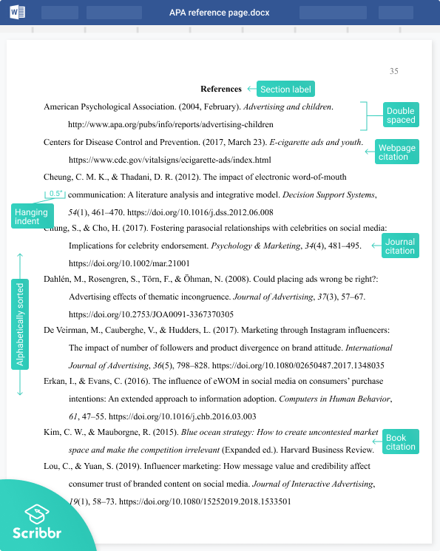

### Anneure IX

### Standard abbreviation relating to Weights, Measures and Calendars

**Weights and Measures Calendar**

|  |  |  |  |
| --- | --- | --- | --- |
| **Abbreviation** | **Name** | **Abbreviation** | **Name** |
| b | Billon | AD | Anno Domini |
| c | Celsius | CE | Common era |
| cc | Cubic meter | BCE | Before common era |
| cm | centimeter(s) | BC | Before Christ |
| cu | Cubic | Cal | Calendar |
| CWT | Hundred weight | Cent | Century |
| f | foot(feet) | d | Date |
| ft | Do part of body | hr(s) | hour(s) |
| gal | gallon(S) | m | mintue(s) |
| g | gram(s) | s | Second |
| gr | grain(s) | Jan | January |
| ha | hectare | Feb | Feb |
| kg | kilogram | Mar | March |
| km | kilometer(s) | Apr | April |
| l | litre | May | May |
| m | Meter/mile/millon(s) | June | June |
| mg | milligram | Jul | Jul |
| mm | millimeter | Aug | August |
| mt | Metric tonne | Sept | September |
| q | quintal | Oct | October |
| sq | square | Nov | November |
| t | tone(s) | Dec | December |
| temp | temperature | Mon | Monday |
| mg | microgram | Tue | Tuesday |
| g | gram | Wed | Wednesday |
| μL | microlite | Thu | Thursday |
|  |  | Fri | Friday |
|  |  | Sat | Saturday |
|  |  | Sun | Sunday |
|  |  | Pa | Per annum |
|  |  | am | Ante meridiem |
|  |  | pm | Post meridiem |